Proposal Summary
Applicant |  | Rachel Hulks
Owner |  | Bonython Nominees Pty Ltd - 231 Pacific Highway,  Mount White
 |  | Ognis Pty Ltd - 20 Ashbrookes Road, Mount White
Application Number |  | PP-2022-1136, RZ/2/2022
Description of Land subject of planning proposal |  | Property Description:  231 Pacific Highway, Mount White  20 Ashbrookes Road, Mount White  Legal Description:  Lot 1 DP 207158 & Lot 1 DP 547622
Site Area |  | 231 Pacific Highway, Mount White - 3.27 hectares
 |  | 20 Ashbrookes Road, Mount White - 10.9 hectares
Existing Use |  | 231 Pacific Highway, Mount White – the site is currently vacant
 |  | 20 Ashbrookes Road, Mount White – Saddles Restaurant operating as ancillary to Saddles Garden Centre since 2018
Proposed Amendments – Central Coast Local Environmental Plan 2022
Provisions | Existing Provision |  | Proposed Amendment | Outcome (Supported/Not Supported)
Schedule 1- Additional permitted use | Nil |  | Lot 1 DP 207158 (231 Pacific Highway, Mount White)  hotel or motel accommodation, restaurant or café and small bar, and to permit a day-spa business premises with maximum floor area limits  Lot 1 DP547622 (20 Ashbrookes Road, Mount White)  restaurant or café, which effectively recognises the existing restaurant/ café/ balcony areas on the site. | Supported
Additional Permitted Uses Map | Nil |  | To include the following properties on the APU map:  Lot 1 DP 207158 (231 Pacific Highway, Mount White)  Lot 1 DP547622 (20 Ashbrookes Road, Mount White) | Supported

Proposal Summary
This Planning Proposal seeks to allow the existing ‘Saddles Restaurant’ that is the main tourist attraction of 20 Ashbrookes Road, Mount White (Lot 1 DP 547622), to operate as a permissible land use. And allow a number of APU’s at 231 Pacific Highway, Mount White (Lot 1 DP 207158) which will permit a range of different land uses to occur on the site. APUs proposed on this site include hotel or motel accommodation, restaurant, or café, a small bar and a day spa business premises, to be added as permissible land uses (with maximum floor area limits).
The Sites
The irregular shaped allotments are characterised by rural settings in the Mount White area, with close proximity to the Pacific Highway and M1 Motorway, as shown in Figure 1. Both allotments are zoned RU1 Primary Production and a portion of Lot 1 DP 547622 is also zoned C2 Environmental Conservation. Surrounding land uses include allotments utilised for rural living and primary production purposes, Vicki Roycroft Horse Stables, Gosford Sandstone Quarry and Mount White Nursery.
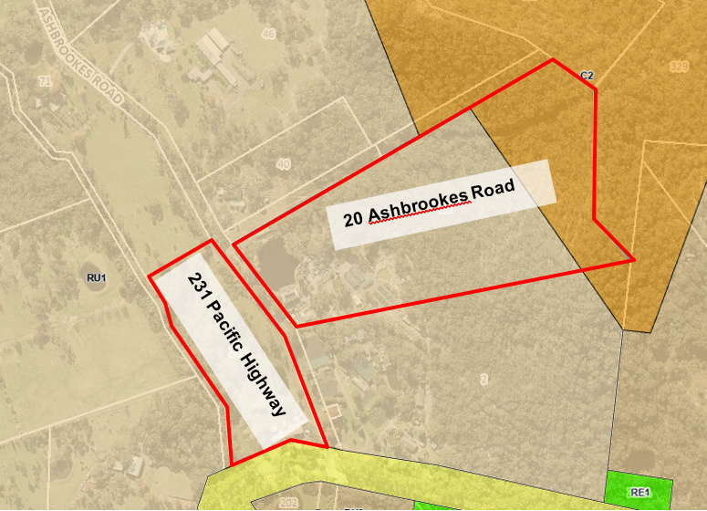
Figure 1 Aerial photo of sites with zoning overlay
20 Ashbrookes Road is currently used as Saddles Garden Centre with Saddles Restaurant operating as an ancillary use to the garden centre since construction approval in 2018 (31/07/2018). This site has been used as a garden centre since the 1990s and adjoins a plant nursery along its southern boundary.
231 Pacific Highway is a vacant site where recent demolition of existing structures on site (dwelling house, cottage and ancillary structures) occurred in 2021. Currently Integrated Dwelling House and Bed and Breakfast Accommodation with four bed and breakfast suites has been approved on the site (DA/6 2053/2021). The site was historically used as Hawkesbury Inn from the 1960s-1980s and a petrol station before that. This site adjoins Vicki Roycroft Stables on its western boundary.
The Proposal
LEP land use definitions to be applied:

hotel or motel accommodation means a building or place (whether or not licensed premises under the Liquor Act 2007) that provides temporary or short-term accommodation on a commercial basis and that—
(a) comprises rooms or self-contained suites, and
(b) may provide meals to guests or the general public and facilities for the parking of guests’ vehicles,
but does not include backpackers’ accommodation, a boarding house, bed and breakfast accommodation or farm stay accommodation.
restaurant or cafe means a building or place the principal purpose of which is the preparation and serving, on a retail basis, of food and drink to people for consumption on the premises, whether or not liquor, take away meals and drinks or entertainment are also provided.
small bar means a small bar within the meaning of the Liquor Act 2007.
business premises means a building or place at or on which—
(a) an occupation, profession or trade (other than an industry) is carried on for the provision of services directly to members of the public on a regular basis, or
(b) a service is provided directly to members of the public on a regular basis,
and includes funeral homes, goods repair and reuse premises and, without limitation, premises such as banks, post offices, hairdressers, dry cleaners, travel agencies, betting agencies and the like, but does not include an entertainment facility, home business, home occupation, home occupation (sex services), medical centre, restricted premises, sex services premises or veterinary hospital.
Both APUs will include maximum floor area limits as follows:

20 Ashbrookes Road:
- Development is to remain at maximum 370m² floor area (220m² of this is outdoor seating areas).
231 Pacific highway:
- Cafe or Restaurant, bar and veranda has a maximum floor area of 380m²(150m² of this is outdoor seating);
- Day spa business premises has a Gross Floor Area (GFA) of 300m²;
- Accommodation lobby, Housekeeping, BOH and Bathrooms has a GFA of 310m²; and
- Hotel or motel accommodation (maximum 20 single room/ suites) has a GFA of 1,040m².

This Planning Proposal seeks to allow ‘Saddles Restaurant’, the main tourist attraction of the site, to operate as an APU rather than as ancillary use to Saddles Garden Centre at 20 Ashbrookes Road, Mount White. And deliver APUs of restaurant, small bar, day spa and hotel or motel accommodation and associated development to provide tourist accommodation/ attraction at 231 Pacific Highway, Mount White.

Assessment
The planning proposal is considered to have strategic planning merit for the following reasons:

- The Planning Proposal will allow the ‘Saddles Restaurant’ to operate as a restaurant or café as a permissible land use and will permit a number of other supporting tourist uses. The restaurant is currently operating successfully as a tourist attraction which promotes the Central Coast’s agritourism, rural areas and bush (Aligning with Direction 3 of the CCRP).
- Council’s Local Strategic Planning Statement 2020 identifies opportunities to broaden the region’s scope of attractions including agricultural destinations that leverage the regions natural assets and scenic qualities, linking agriculture and appropriate forms of rural tourism.
- The Central Coast Regional Plan (CCRP) 2036 supports the development of rural areas that can adapt to changing agricultural trends and practices. The proposal will provide additional local employment opportunities by increasing rural economic productivity through securing existing jobs and creating new jobs (Aligning with Direction 7 of the CCRP). It also diversifies the rural economy, while minimising land use conflicts to adjoining rural properties, primary production use properties and extractive industries by maintaining adequate buffers (Aligning with Direction 11 of the CCRP).
- The proposal is also consistent with the Agritourism initiatives being introduced by the state government which aim to support rural economies across NSW.
- All site management issues with traffic, wastewater disposal, vegetation removal and land use conflicts can be adequately managed based on the information provided in supporting studies.

